The Ohio State University Extension
Seneca County 4-H Family Newsletter

Volume 27, Issue 3 July-September | 2017

In this issue……….
- Kick Off/Family Fun Night
- 2017 4-H Camp
- 2017 Cloverbud Camp
- Cloverbud Kit
- 4-H Advisory Council Scholarships and Awards
- Senior 4-H Members
- Cloverbud Graduation
- Pre-Fair Judging
- Farm Bureau Information
- Booth Information
- Milkshake Stand and Booth Patrol Schedules
- County Apparel Order
- STEM at the Fair
- STEM Fun Day
- Volunteer fingerprints and forms
- Grade A Celebration
- Rabbit Clinic
- 4-H Sundays at Subway
- Suicide Prevention Program
- Jr. Fair Information
- Project judging dates, locations, and projects judged
- Booth Patrol Schedule
- MilkshakeStand Schedule

Welcome to Fair Season!
Summer is flying by and we are entering the very busy fair season. This year is a very special year for the Seneca County Fair as we celebrate 175 years!

This newsletter will be the last one before the fair so please make sure to check out the judging schedule, Milkshake Stand and Booth Patrol schedules, and all the livestock interview and skill-a-thon times.

If you have any questions about judging requirements, times, or any questions regarding the fair please contact the Extension Office or the Jr. Fair Office.

Good luck to all our 4-H members as you prepare for judging and shows and to our advisors as you prepare as well. Have a great rest of the summer and see you all at the fair!

OSU Extension, Seneca County

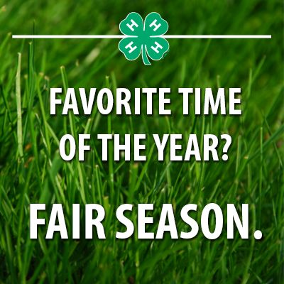

Kick Off/Family Fun Night
Thank you to all who attended the annual Kick Off event on May 12th. We enjoyed games, face painting, and meeting new people. We would like to extend a special thanks to 4-H Advisory Council for their support and to Landing Point Financial for providing pizza and pop again this year.

2017 Seneca County 4-H Camp
This year 93 campers “Took the Stage” at 4-H camp during the 2017 4-H camp held at Kelleys Island. Campers enjoyed Hollywood themed activities, crafts, dances, swimming, and recreation time. Thank you to the camp counselors and adult staff who put in many training hours and time at camp.

Camp Counselors and Staff
Kristan Bowers Cara Brown
Jared Clark Kady Elchert
Maddy Elchert Cate Frankart
Becky Greene Terri Greene
Kylie Hemchak Nura Himebaugh
Samantha Hinton Cynder Jameson
Wilbur Jameson Jordan Kieffer
Alesha Lowry Alesha Lowry
Ethan Marks Garrett McCoy
Logan McCoy Rachel Miller
Colton Price Makennah Rettig
Allison Staib Adrianna Stock
Matt Warner Emily Willman

Brad Boes Katie Cole
Jozie Hickman Ian Warnament
Alix Siemer Debbie Schultz
Adam Wright

2017 Cloverbud Camp
Cloverbud Camp will be Tuesday, August 15 from 9:00 a.m. to 3:00 p.m. at Meadowbrook Park in Bascom. Youth must be at least five years old and in kindergarten as of January 1st of the current year. Registration fees will be $30.00. Lunch and a t-shirt will be included. Registrations and a flyer can be found on the website Seneca.osu.edu.

Cloverbud Kit
A new Cloverbud kit is now available in the office for you to check out and use with your Cloverbuds on Weather Fun. The kit includes weather icebreakers and games, songs, crafts, ideas for weather related snacks, science experiments, careers in weather, a community service project, and a storybook. Stop into the office if you are interested in using it.
4-H Advisory Council Scholarships and Awards
The Seneca County 4-H Advisory Council has several scholarship and award opportunities for all 4-H members. The application is online or available at the Extension Office. All applications are due to the Extension Office by July 13, 2017.
Scholarships and Awards available:
- The Golden Award: Presented at the Grade A Celebration on Sunday, August 27, 2017 to two first or second year 4-H members and does not include Cloverbuds. Each winner will receive $50.00.
- Home Economics Award: Presented to one 4-H member who is 16 years or older and has significant experience in 4-H Home Economic projects. The recipient will be announced on Monday, July 24, 2017 during the King and Queen contest. The winner will receive $50.00 and a certificate.
- I Dare You Award: Presented to two 4-H members who are 16 years old or older. Members should exhibit exemplary leadership skills. The winner will receive $50.00, a certificate, and the I Dare You book. The recipient will be announced on Monday, July 24, 2017 during the King and Queen contest.
- 4-H Advisory Council Scholarship: Presented to two 4-H members who are incoming college freshmen with significant 4-H and community involvement. Member should exhibit leadership experience and potential. Scholarships are $250.00/piece and will be presented on Monday, July 24, 2017 during the King and Queen contest.
- Seneca County 4-H Program Memorial Scholarship: Presented to one 4-H member who is a graduating high school senior and will be an incoming college freshman. Recipient should have significant 4-H and community involvement. This member should also exhibit leadership experience and potential. This scholarship is in memory of the members of the Seneca County 4-H family who have passed. An essay of no more than 500 words must accompany this scholarship explaining the importance of giving back. This will be awarded on Monday, July 24, 2017 during the King and Queen contest.

Senior 4-H Members
Graduating seniors should have received information to fill out to be recognized in our senior booth at the fair. Please take a moment to fill out the form so we can recognize you and all you do! Pictures (4x6) and information will need to be returned to the Extension Office no later than July 14, 2017 to be included in the booth. If you do not turn in a picture and information, your name will still be included in the booth.

Cloverbud Graduation
New this year, we will be honoring our Cloverbud members who will become traditional 4-H members next year! Families and friends are invited to the Cloverbud Graduation Ceremony on Friday, July 28, 2017 at 4:00 p.m. in the Educational Building. Information forms are being sent out to families, please fill out and return to the Extension Office by Friday, July 21, 2017.

Pre-Fair Judging Dates and Information
There are three dates for pre-fair judging. A list of projects, the dates, and a judging schedule are included at the end of the newsletter. If you are unable to attend your scheduled judging date, your project must be judged by an advisor and are not eligible for county or state awards. Dates will July 12 (Sentinel), July 15 (Fairgrounds), and July 22 (fairgrounds). Judging will be by club again this year. Please check the schedule for your clubs time slot. If you have any questions on judging times and projects, please call the Extension Office.

Farm Bureau Information
Advisors, do not forget to pick your livestock exhibitors t-shirts. A schedule for pick up times will be released closer to the fair. Please consider sending a thank you note to Farm Bureau for their generous donation to members.
Farm Bureau is looking for help in the Dairy Bar during the fair. If you club has previously helped and would like the same time slot, either call the Extension Office or contact Patty Price at the Farm Bureau Office. If you are interested in taking a shift there are still times available.
- Thursday, July 27, 2017 3:00-6:00 p.m.
- Friday, July 28, 2017 7:00 -11:00 a.m.
- Saturday, July 29, 2017 3:00-6:00 p.m.
The Farm Bureau is able to provide this service and lower food costs to 4-H members and their families but they need our help. Please contact the Extension Office or the Farm Bureau Office to fill a shift.

Booth Information
Booth set-up will be Saturday, July 22, 2017 from 9:00 a.m.-9:00 p.m. and Sunday, July 23, 2017 from
12:00 p.m. - 5:00 p.m. Club packets will be available during this time.
Booth tear down will begin at 6:00 p.m. on Sunday, July 30, 2017. NOTHING will be released prior to 6:00 p.m. The booth building will close at 5:45 p.m. and reopen at 6:00 p.m. to begin tear down. Clubs may also tear their booth down on Monday, July 31, 2017 from
8:00 a.m. - 12:00 p.m.

There is one spot remaining for booth patrol. Clubs displaying items in the county booth are required to take a shift for booth patrol. Even if those clubs want to combine for a shift, it would be appreciated! The remaining shift is on Saturday, July 29, 2017 from 7:40-9:45 p.m. It does not have to be a club, if any families or groups are interested in doing it please contact the Extension Office.

Milkshake Stand and Booth Patrol Schedules
Both schedules are included at the end of the newsletter. If you are splitting a shift with another club, please make sure to contact them to ensure coverage time.

County Apparel Order
There will be a second round of Seneca County 4-H apparel orders. The website will be active http://threadesigns.com/2017_seneca_county_4h_shirts
And we will accept the hard copy order forms as well. Orders will be accepted July 1, 2017- August 7, 2017. Orders will be available for pick-up at the Grade A Celebration on August 27, 2017.
If you ordered in April and have not picked your items up, please stop in the Extension Office.

STEM at the Fair
A new event at the fair this year will be STEM activities. At 1:00 p.m. on Wednesday, July 26 and Thursday, July 27 in the booth building. Come check it out.

STEM Fun Day
Come to the Extension Office and spend your last day before school doing some fun and interactive STEM activities on Tuesday, August 22, 2017 from 9:00 a.m. -3:00 p.m. Learn about electrical circuits, robotics, engineering, and the arts. Registration is open to 4-H members 8-18. Registration fees are $30.00 and includes lunch. Forms are available on the county website.

Volunteer Fingerprints and Enrollment Forms
If you were selected to get your fingerprints done and have not yet, please get this done immediately. You will not be considered a volunteer if it is not done. You can bring your receipt and reimbursement form to the office to be reimbursed from the University.
Also, if you did not turn in an enrollment form please get those turned in immediately. Enrollment forms should be filled out each year.

Grade A Celebration
The Grade A Banquet has a new name this year! It is now going to be called the Grade A Celebration. This is event is sponsored by the Tiffin and Fostoria Kiwanis and recognizes our members who received an A on their project. We also recognize our advisors and volunteers that put forth a lot of time and effort in helping our 4-H clubs and programs thrive. This will be held on Sunday, August 27, 2017 at 6:00 p.m. in the Entertainment Building at the fairgrounds. The meal will include picnic type food. Members who received an A will be free of charge and advisors will also be free of charge this year. Registrations forms and further information will be available soon. Payments and registrations will be taken again at the Extension Office this year.

Rabbit Clinic
You are invited to work with your rabbit(s) on July 10, 2017 at 7:00 p.m. in the rabbit barn at the fairgrounds. You many bring your rabbit with you and help learn how to handle them. Rabbit tattooing will also be available.

4-H Sundays at Subway®
Do you love 4-H? This summer, you can show your support for 4-H Healthy Living programs and help our state win $15,000.00 just by visiting your local Subway® restaurant on Sundays this summer. Each Sunday this summer, June 25-August 27, participating Subway® restaurants will make a donation to our local 4-H Healthy Living program. You could win a free $5.00 gift card yourself every time you visit and participate in the photo contest promotion. Here’s how it works:
Enjoy a meal and share your 4-H Sundays at Subway® by snapping and sharing your photo with your Subway® meal. Make sure your photo is in-store or includes the wrapper. Go to 4-H.org/4HSundayContest, enter your info (including the state you want to receive the grant), upload your photo, and click “share” to have it posted across your social media platforms. Or post on Instagram with #4HSundayContest and your state. (#OH)

Suicide Prevention Program
Do you know the three steps that could help someone in a mental health crisis?
- Ask RUOK
- Know the Signs
- Take Action
Thank you to our friends at the National Alliance on Mental Illness (NAMI), whose training is funded by levy funds through Mental Health Recovery Services Board of Seneca, Sandusky, and Wyandot Counties, for offering valuable suicide prevention training on June 13. Also, a huge thank you to Kelly Marker for arranging the training, Jill Gosche for publicizing, Kelly’s family, Rita Houtz, and Seneca County 4-H Advisory Council for providing refreshments. Thank you, too, to Mental Health and Recovery Services Board for the literature and bracelets. Finally, thank you to all who attended. As Melanie White told those who participated, some day, every person in attendance would save a life, even if they don’t know it.

We will be trying to arrange some additional dates for training and awareness. If you would like additional information, there are some brochures in the Extension Office.

If you or anyone you know is in need of help, NAMI does offer a 24 Hour Crisis Hotline 1-800-826-1306 or you can text 4hope to 741 741.

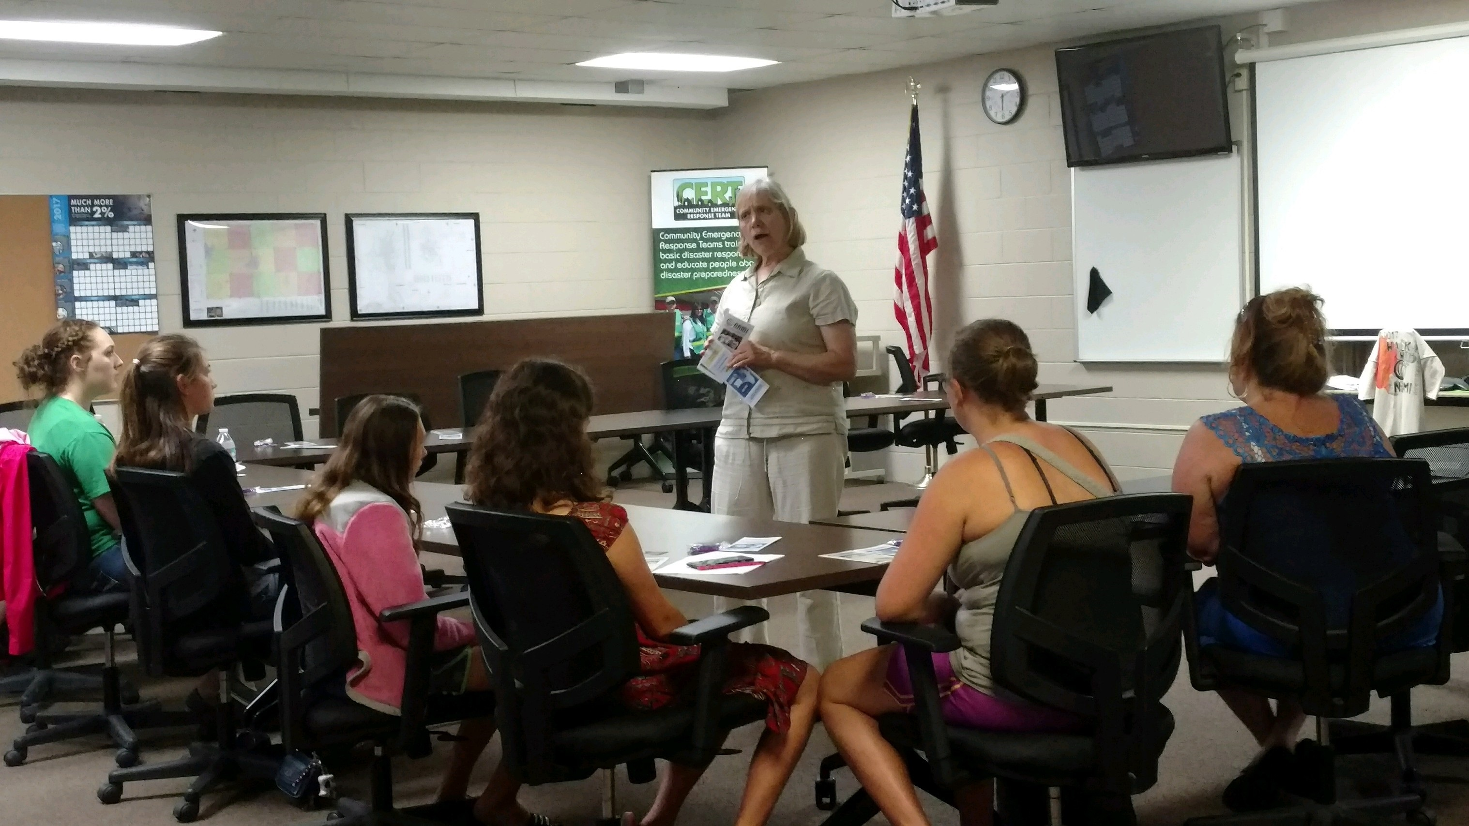

Jr. Fair Information from Nicole
Office hours and workdays: Office hours will be Tuesday’s from 9:00 a.m. – 3:00 p.m. The office will be closed July 4 but will be open on Friday, July 7. Remaining work days in July Include: Monday, July 10, Thursday, July 20, and Friday July 21 from 9:30 a.m.-12:30 p.m.
Skill-a-thon and Interview information
- Swine- Thursday, July 13, 2017, 5-8 p.m., Youth Center. Schedule is as follows and only applies to the Swine Dept.
  - 5:00- Scheduling conflict members
  - 5:30- FFA members, Bloomville Good Luck Sheep, 4-H Guys and Gals, Attica Dairy, New Riegel Rawhides and Woolies, Eden Dairy, and Eastern Co. Livestock
  - 6:00- Hopewell Hog and Dairy, Eden Jr. Farmers, Backroad Barnyards, Seneca Jr. Farmers, and Spirit of ‘76
  - 6:30- Kids, Pigs, and Udders, Clinton Farmers, Blue Ribbon Buckeyes, Republic Rowdy Rednecks, and Seneca CPA’S
  - 7:00- Swine Stockade, McCutchenville Wide-Awake, Bloomville Beef and Feeders, Roots and Wings, Seneca Helping Hands, and Victory 4-H
  - 7:30- Anyone not listed above
- Goats- Saturday, July 15, 2017, 9-11 a.m., Youth Center
- Poultry- Monday, July 17, 2017, 5-8 p.m., Youth Center
- Canine- Tuesday, July 18, 2017, Education Building. Skill-a-thon runs from 6-8 p.m. and royalty interviews at 6 p.m.
- Sheep- Sunday, July 23, 2017, following weigh-in, Livestock Pavilion
- Beef and Dairy- Monday, July 24, 2017, 8-9:30 a.m., Super Barn
Sale Information
The livestock sale committee is asking families to donate a case of water for the buyers at the sale. Please drop cases off at the Jr. Fair Office. Clubs have been assigned to help pass out water and clean up following the sale.
- Water 9-11:30 a.m.- Eastern Co. Livestock, Eden Jr. Farmers, Eden Jr. Hoppers, 4-H Guys and Gals, Hopewell Hog and Dairy, McCutchenville Wide-Awake, Backroad Barnyards, New Riegel Rawhides and Woolies, and No Limits.
- Pass out lunches 11:30 a.m.- Bloomville Good Luck Sheep
- Water 12:00-2:30 p.m.- Jolly Workers, Republic Rowdy Rednecks, Seneca CPA’s, Seneca Co. Jr. Farmers, Seneca Helping Hands, Seneca Co. Jr. Beef, and Seneca Pens and Friends.
- Water 2:30-5:00 p.m.- Kids, Pigs, and Udders, Roots and Wings, Spirit of ’76, Swine Stockade, Thompson Toilers, Victory 4-H, FFA Chapters.
- Clean up sale ring and tear down- Attica Dairy, Bloomville Beef and Feeders, Blue Ribbon Buckeyes, Buckeye Buddies, Buckeye Clover Bunch, Bloomville Busy Beavers, Circle E, Clinton Farmers, and Eden Dairy.

Jr. Fair Board Happenings during the Fair……..

**Jr. Fair Fun Nights- every night in front of the Jr. Fair Office Tuesday-Saturday 6:00 p.m.

** Annual Sub Eating Contest, sponsored by Subway, will be held on Sunday, July 30 at 5:30 p.m. Teams must consist of four members. Sign up at the Jr. Fair Office.

**Premium Pick Up
- Friday, July 28, 2017 from 10:00 a.m. to 3:00 p.m.
- Saturday, July 29, 2017 from 1:00 p.m. to 5:00 p.m.
- Sunday, July 30, 2017 from 1:00 p.m. to 5:00 p.m.

Jr. Fair Passes will be available for sale at pre-fair judging on July 12 at Sentinel and the Jr. Fair office will be open during the July 15 judging at the fairgrounds.

Project Judging Dates, Locations, and Projects Judged
Below is a list of dates, times, and projects that are judged on the respected days. If you do not see your project below, contact the Extension Office. If you are taking a Self-determined project and are not sure which day you should attend, contact the Extension Office. Members should attend the judging date that is assigned to their project. If you are unable to attend your judging date, you must have an advisor judge your project and you will not be eligible for county awards or state fair. Please make sure to check the list for when your project is judged. Attending the wrong judging date will also result in members being ineligible for county awards and state fair.

Saturday, July 15, 2017 at the Fairgrounds

Vet Science: From Airedales to Zebra, All Systems Go!, and On the Cutting Edge.

Woodworking: Measuring Up, Making the Cut, Nailing it Together, Finishing Up, Woodworking Master, and Self-determined Woodworking.

Cats: Purr-fect Pals, Climbing Up, and Leaping Forward.

Tractors: Starting Up, Gearing Up, Moving Out, and Learning More.

Electricity: Magic of Electricity, Investigating Electricity, Wired for Power, Entering Electronics and Science Fun with Electricity.

Small Engines: Crank it Up, Warm it Up, and Tune it Up.

Conservation: Explore the Outdoors, Exploring Ponds, Why Trees Matter, Ohio Birds, Trapping Muskrats, Fishing for the Beginner, Fishing for the Intermediate, Beekeeping, Teaming with Insects 1, 2, and 3, Safe Use of Guns, Basic Archery, Archery Projects, Shot Gun Project, Rifle Project, Pistol Project, and Natural Resources Self-determined.

Science, Technology, Engineering, and Math: Rockets Away, Science Fun with Flight, Rockets Away, Solid Fuel Rocketry Master, Electric Radio Controlled Vehicles, and Robotics 1 and 2.

Misc. Projects: Cavy, Pocket Pets, Science Fun with Kitchen Chemistry, Science Fun with Physics, ATV Safety, Lawn Care, Crops, Arcs and Sparks, Not Just Knots, Bicycling 1 and 2, and Self-determined.

Saturday, July 22, 2017 at the Fairgrounds

Gardening: How Does Your Garden Grow?, Grow Your Own Vegetables, and Growing with the Seasons.

Monday, July 24, 2017 at the Fairgrounds

Horseless Horse

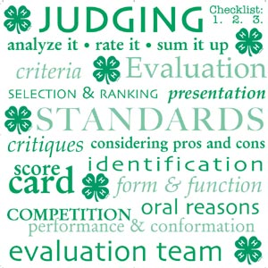

Wednesday, July 12, 2017 at Sentinel Career Center
Clothing: The Laundry Project, Loungewear, Accessories for Teens, Sew Fun, Fun with Clothes, Sundress and Jumpers, Tops for Tweens, Em*bel*ish*, Sew for Others, Active Sportswear, Clothing for Middle School, Shopping Savvy, Clothing for High School and College, Creative Costumes, Dress Up Outfit, Outerwear for Anywhere, Look Great for Less, Clothing for Your Career, Clothing Master, Non-Sewing Master, You Can Quilt, and Quilting for the Better.

Food and Nutrition: Let’s Start Cooking, Sports Nutrition 1 and 2, Snack Attack, Fast Break For Breakfast, Let’s Bake Quick Breads, Yeast Breads, Grill Master, Star Spangled Foods, Party Planner, Racing the Clock to Awesome Meals, Dashboard Dining, You’re the Chef, Global Gourmet, Beyond the Grill, Pathways to Culinary Success, Science Fun with Dairy, Cake Decorating, and Caning and Freezing.

Photography: Focus on Photography, Controlling the Image, Mastering Photography, and Photography Master.

Health: You’re the Athlete, Staying Healthy, Keeping Fit, First Aid in Action, Alcohol and Drug Abuse, and The Truth About Tobacco.
Leadership: One on One, Club Leadership, Club Leadership 2, Diversity, My Hands to Larger Service, Teens on Board, Leadership Road Trip, Pantry Panic, and Leadership Master.

Child and Family Development: Growing on My Own, Growing with Others, Growing in Communities, and Family History Treasurer Hunt.

Money Management: Becoming Money Wise and Teens on the Road to Financial Success.

Communication: Finding Your Voice

Home Living: Adventures in Home Living, Makeover My Space, and Your First Home Away From Home.

Misc. Projects: My Favorite Things, Scrapbooking, Discovering 4-H, Get Started in Art, Play the Role, Become a Puppeteer, Set the Stage, Writing and Reporting for Teens, The Writer in You, and Am I Ready for Work?.

3140 South State Route 100, Suite E
Tiffin, Oh 44883

Phone- 419-447-9722
Fax- 419-447-

CFAES provides research and related educational programs to clientele on a nondiscriminatory basis. For more information: http://go.osu.edu/cfaesdiversity.

