Seneca County
4-H Takes The Stage
Your registration for the Seneca County 4-H camp has been received. We are pleased that you have decided to attend camp. We hope you are as excited as we are about our three days at Kelley’s Island. There are many fun activities planned, and we cannot wait to share them with our campers.

This newsletter is a 4-H Camp Information Packet. We hope the material included in this newsletter will aid you and your parents in preparing for a fun-filled time at camp. Included in the newsletter is information on programs, directions, emergency numbers, packing lists, health forms and much more.

Please read the articles carefully. It is all very important information. Pay special attention to due dates and time schedules for drop off and pick up at the ferry.

We look forward to seeing you on June 27th, and hope the information in this packet will answer your questions and concerns. If you need clarification or have any unanswered questions, feel free to call our office at, 419-447-9722. Have a great summer and we will see you soon!

Sincerely,

Katie Cole
Extension Educator
4-H Youth Development
Table of Contents

Emergency Number & Health Concerns 2

Ferry Info, Check In, & Pickup 2

Packing for Camp 3

Preparing and What to Expect 4

Seneca County
4-H Takes
The Stage
Thank You Donors

Jr. Fair Foundation
&
Union Grange
Tuesday, June 27th through
Friday, June 30th
Kelley’s Island, Ohio
Health Forms & Concerns
Check In at Ferry

Will include:
- Drop off your luggage.
- Get your name tag and cabin assignment.
- Turn in any medication to camp nurse.
- Meet your counselors and cabin mates.
Health forms are enclosed with this newsletter. These must be turned in by June 21st to the extension office.

Medications:
Any physician-prescribed or over-the-counter medicine, which is brought to camp, will be turned over to the camp nurse on Tuesday at camp check-in. Please do not pack medication in your child’s luggage.

All medications must be in original package. Bottles and boxes should be labeled with the camper’s name, and any specific instructions. If your child has multiple medications, please enclose them all in a large plastic bag and zip it shut. For additional information on medications, see the Health Form.

If your child is used to taking medication at
home or school, please do not use camp as a
time to “take a break” from it. Campers have many new experiences at camp and they need to feel their best to do so.
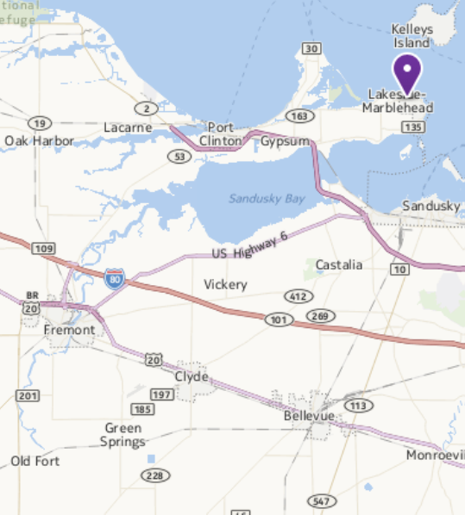
Camp Emergency Number
Finding the Dock
In the case of an emergency, you can contact the camp staff by calling (419)-746-2794. Again, this is only for emergencies.

Likewise, campers will not have access to a phone. Outgoing calls will only be placed for serious reasons with approval from the camp director. Cell phones are not permitted at camp.
2

Pick up at Ferry
- Campers will remain with their counselor until all luggage is unloaded.
- Before campers leave check with the camp nurse for medications.
- Check-out with your child’s counselor. You will need to sign a camper check out form before leaving with your child.

We will be departing from Kelley’s Island Ferry Boat Lines, on Tuesday, June 27th. Please arrive at the dock between 12:30pm and 1:00pm. The campers will begin boarding the ferry at 1:30pm.

Please feed your child lunch before coming. We will be arriving at camp after lunch.

We will be returning on Friday, June30th beginning at 3:00pm. Again, we will be coming in at Kelley’s Island Ferry Boat Lines. The ferry lines keep a tight schedule. Please be there on time to pick up your child.

The map on the right and the directions below explain how to get to our departure and arrival point

To Marblehead: Ext Rt. 2 at 269 North. Take 269 N to Rt. 163. Turn right onto 163 East.

In Marblehead: The Kelley’s Island Ferry Boat Lines is at 510 West Main Street across from Marblehead Police Department and Fire Station.

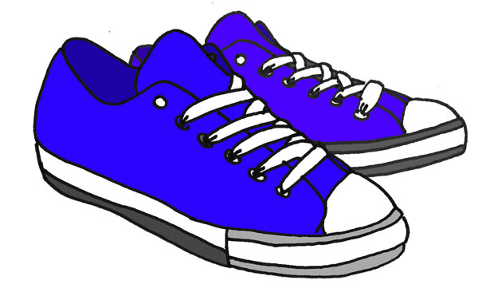
*Note on Shoes*
Packing List
*Only bring one piece of luggage per camper*
(plus sleeping bag/bedding)

Tennis shoes are highly recommended for most activities. Bring at least one (preferably two) pairs of comfortable shoes such as running, walking, or cross training shoes. These shoes are required for most activities at camp for safety reasons. Campers should bring one pair of flip-flops/sandals while walking to and from the beach and to the showers. These are the only occasions when a camper can wear flip-flops at camp. Campers are permitted to bring sandals (they must have a strap around the heel) to wear during some (but not all) camp activities. They may be brought if desired but not required.

- Sleeping bag or 2 blankets and 1-2 sheets
- Pillow and pillowcase
- Towels and washcloth
- Soap, comb/brush
- Toothpaste and toothbrush
- Insect repellent
- Swimsuit and beach towel
- Raincoat (carry on ferry if
raining)
- Jacket or sweatshirt
- Everyday sport/play clothes and sleepwear
- Flip flops to wear to the restroom*
- Two pairs of tennis or old shoes (One to wear, one to keep dry, one for beach activities)*
- Bring socks to avoid blisters
- Flashlight
- Sunscreen
OPTIONAL
- Pen, pencil, stationary,
stamps
- Canteen money**
- Theme oriented costumes and accessories
- Camera (at own risk)
WHAT NOT TO BRING TO CAMP
- Expensive sports equipment, iPods, video games
- Cell phones
- Knives, fireworks, firearms, and tobacco
- Jewelry, expensive shoes and clothing
- No drinks are permitted in the cabins
THREE THINGS YOU DON’T WANT TO FORGET
- Insect repellent
- Sunscreen
- Extra tennis shoes
Please tie all luggage and sleeping bags very securely! Campers should have all bedding, including pillow, tied together or in a trash bag with their name on the outside.

**Canteen Bank**

We will operate a Canteen bank where campers turn their money in on Tuesday at camp and will receive the balance on Friday morning. Canteen items can be purchased during dance times. Primary items available are snacks and drinks ranging from $0.50 to $2.00 and souvenirs ranging in prices from $7.00 to $20.00. We encourage you to keep spending money to a minimum. We recommend no more than $25.00. It is very helpful to the 4-H Camp staff if campers bring small bills – we suggest no larger than a $5 bill.
Please put all money in a sealed envelope or plastic bag marked with your child’s name. Pack this in their luggage (parents, be sure your camper knows where this envelope is.)

Lost and Found

All lost and found articles left at 4-H camp will be kept in the Extension office for 2 weeks after camp. After 2 weeks, items will be donated to the needy. It helps us return items if you have the camper’s name on each item! (clothing, towels, etc.) Please check the lost and found on Friday morning!

Label all items with permanent ink and bring
a list of all your things

3

Kelley’s Island gets its mail by boat causing a slight delay in mail time. Plan on mailing letters by Thursday, June 22. If you write “Seneca County” on the back of the envelope, the camp staff will hold it until our campers arrive.
Camp Address:
Name of Camper
4-H Camp – Seneca County
403 Ward Rd
Kelley’s Island, OH 43438

7:00am Rise and Shine!!
8:00am Breakfast
9:15am Flag Raising
9:45am AM Session
11:00am AM Session
12:30pm Lunch
2:15pm PM Session
3:30pm Large Group Activity
4:00pm Camp Clean-Up
4:15pm Organized Free Time
5:30pm Dinner
6:45pm Flag Lowering
7:00pm Evening Program
7:45pm Group Mixers
8:15pm Dancing/Movies
10:30pm Vespers
11:00pm Lights Out
Camp Mail
Activity Sessions
Campers have the opportunity to choose a number of their own sessions before session times. Other camp activities include: large group games, swimming and beach games, team challenge, camp songs, evening dances, campfire, counselor skit, and more.

- Talk with other parents and friends about their experience. Introduce the child to others who have been to camp or who will attend camp.
- Parents should talk with campers about the importance of cleanliness and wearing sunscreen.
- Prepare the child to care for themselves. Have them practice camp skills at home: choosing their clothing, making their bed, setting the table, staying with a friend for a weekend.
- While at 4-H camp, campers will be learning to live in a group atmosphere. They will be expected to assist with clean-up chores such as sweeping, washing off tables, and trash pick-up. It is also expected of campers to keep their own belongings and bunk neat and tidy.
- Problem-solve with the child. Discuss ‘what if…. You lost your shoes at camp? You didn’t feel well? You didn’t remember where to go?
- Talk about how to cope with missing home. Pack a family picture. Feeling lonesome is okay. Talk about having fun too!
- Prepare yourself (the parent) for separation. You may have mixed feelings when you actually leave. Camp is a positive experience for your child.
- Avoid statements like “If you don’t like camp you can come home.” Children who are experiencing difficulties adjusting to camp may compound their problem by not giving it a fair chance. Often they will close their minds to adapting to camp, and focus immediately upon going home.
A Typical Camp Day
Topics to Discuss Before Camp
4

Informed Consent and Permission to Participate
Seneca County 4-H Jr. Camp

I give permission for my child, _________________________________, to participate in the Seneca County 4-H Jr. Camp at Kelleys Island 4-H Camp from June 27-June 30, 2017. Activities involved in camp will include living in a cabin; sharing bathroom facilities with other campers; sleeping in bunk beds; canoeing, swimming, nature hikes, shooting sports; playing volleyball, basketball, relay races and other recreational games; campfire activities; and dances. Attending the camp may lead to contact with individuals who are experienced and inexperienced in the above activities. I also understand that participation in this activity is strictly voluntary and is not a requirement for 4-H membership.
I am aware and have discussed with my child that:
- Being in and around water, woods, and participation in camp activities may cause clothing to become wet, dirty, and beyond cleaning and/or repair;
- While in a canoe, my child may be involved in a collision with another canoe, person, or object in the water;
- Hiking may give rise to risk of injury arising from the surface or subsurface of the ground on which the hiking occurs;
- Participation in sporting/recreational events may give rise to injury as a result of collisions with other individuals or sudden falls;
- Other participants may act in a negligent manner which otherwise may result in harm to my child;
- Swimming may lead to injury caused by slippery surfaces, contact with other swimmers and/or objects in the water;
I recognize that the above outlined activities and potential resulting risk may cause injury, death, drowning, or loss to participants or other persons in the immediate vicinity.
I understand that my child is not required to participate in this activity, but grant permission for him/her to do so, despite the possible risks. I recognize that by participating in this activity, as with any physical activity, my child may risk personal injury. I hereby attest and verify that I have been advised of the potential risks, that I have full knowledge of the risks involved in this activity and that I assume any expenses that may be incurred in the event of an accident, illness, or other incapacity, regardless of whether I have authorized such expenses.

Signed:_________________________________ Date:____________________
(Parent/Guardian)

Signed:_________________________________ Date:_____________________
(Camper)

Searching Belongings
If there is reasonable suspicion that a violation of the program’s prohibited items policies has occurred or other rules have been broken, a search may be conducted. The following steps will be taken:
- Searches will be conducted by at least two (2) trusted individuals, in the presence of the participant whose belongings are being searched, and preferably in a private setting, unless there is imminent danger or circumstances that require immediate action.
- Searches may include a participant’s luggage, bags, backpacks, knapsack, trunk, locker, bedding, dresser drawers, and personal effects including toiletries.
- When timing and circumstances allow, the participant’s parent or guardian will be notified prior to conducting the search. In situations when this is not possible, either due to timing, lack of communications coverage, or lack of response, notification will be made as soon as possible.
- If an illegal item is discovered (e.g. alcohol), it will be confiscated and retained in a secure place, and the appropriate authorities will be contacted for further action.
- If a prohibited item is discovered, it is confiscated and retained in a secure place. Prohibited items may be returned to the parent/guardian when they arrive to pick-up their participant.

Ohio 4-H Camp Cell Phone Policy
As a means of risk management, youth participants (campers and counselors) may not possess cell phones* during 4-H camp. Counselors shall not use cell phones (as alarms, music players, etc.) in their cabins at any time. Camp Program Directors have discretion for permitting camp counselors selective cell phone use during limited time periods, such as during out-posting, nature treks, or off-camp travel (field trips), or for other safety concerns where the use of two-way radios is not practicable. Camp Program Directors will determine consequences for possessing a cell phone. The State 4-H Office recommends a zero tolerance approach: If an individual is caught with a prohibited cell phone, they will be sent home at the family's expense.

* Camp Program Directors also have discretion for prohibiting other internet-enabled devices at their 4-H camps.

I, ____________________, acknowledge that camp staff reserves the right to search and seize any illegal or prohibited items in my child’s luggage, bags, backpacks, knapsack, trunk, locker, bedding, dresser drawers, and personal effects including toiletries. I, also, acknowledge that cell phones are not permitted at camp and will be confiscated if found.

Signed: ________________________________ Date:_______________ (Parent/Gaurdian)

Signed: ________________________________ Date:_______________
(Camper)

